Project Name: SauceDemo Manual Testing
Version: 1.0
Test Cycle: Sprint 1 & Sprint 2
Date: 19th February 2026
Prepared By: Amrutha M

1.Executive Summary
The testing of the SauceDemo e-commerce application has been completed.
The focus was on core functional workflows including Login Authentication, Product Management, Cart Management and Checkout process. While the application is functional for the standard_user, significant issues were identified when testing with specialized user personas (problem_user, error_user, visual_user, performance_glitch_user).
Testing was executed and tracked using the Zephyr Scale plugin within Jira to ensure full traceability between requirements, test cases and defects.

2.Test Scope vs. Execution
- Planned Test Cases: 55
- Executed Test Cases: 55
- Passed: 36
- Failed: 19
- Pass Percentage: 65.4%
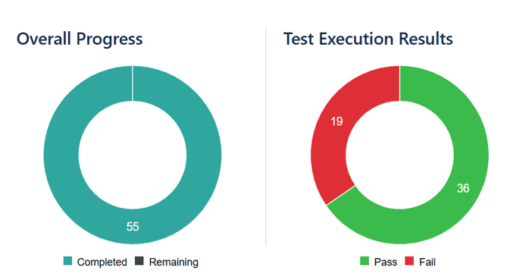
3.Defect Analysis
A total of 19 defects were logged during the execution phase.
3.1 Defect Severity Breakdown
Severity | Count | Status
Critical | 3 | Open
High | 4 | Open
Medium | 9 | Open
Low | 3 | Open

4. Requirement Traceability Summary
Based on the RTM, we have achieved 100% test coverage for the 19 identified requirements. However, 13 out of 19 requirements have at least one associated failed test case, primarily due to the intentional defects designed for the SauceDemo site.

5. Lessons Learned & Recommendations
- Cross-Browser Consistency: Testing was limited to Chrome. Future cycles should include Safari and Firefox to verify if UI alignments are browser-specific
- User Persona Management: Testing with different personas successfully uncovered edge cases that a standard user would not encounter
- Recommendation: Due to the Critical and High severity bugs in the Checkout and Product Listing functionalities, the application required bug fixes and a full regression cycle before release
6. Exit Criteria Status
Exit Criteria | Status | Comments
100% Execution | MET | All 55 test cases executed
Critical/ High Bug Resolved | NOT MET | 7 Critical/High bugs remain open
RTM completed | MET | Traceability is documented

